Sultan Qaboos University

College of Science – Department of Computer Science

COMP3700: Introduction to Web Computing – Spring 2023

Project - Part Two - XHTML and CSS

SQU Market

Team Members: ID:

1. Mohammed Mattar Alshamsi 122711
2. Ahmed Said Alghafri 129520
3. Ammar Abdullah Al Balushi 137497

Table of Contents:

Website target audience/stakeholders: 3

Main objective: 4

References to similar websites: 4

Website contents: 4

Website Structure: 5

Website logo: 5

Database: 6

Web hosting: 6

Google site: 6

Impact issues 7

Ethical and professional issues: 7

Updated Website Structure: 8

Website Pages: 9

Website CSS/Bootstrap Styles Used: 13

The Website: 14

Contribution Table: 14

# Website target audience/stakeholders:

Stakeholder: Khalid SQU student / Salim SQU student

Ammar: Hello Khalid and Salim, we are thinking of building a website to SQU students that provides services and products from the students them self to other students. Do you have any features that we should include on our website?

Khalid: Yes, I would like to you to add a place on the website where you can see all the products and services of the students on one page which will simplify finding all the services on the website.

Salim: I would like to you to add a search bar where you can search for the service or the product, so it is easier to find a specific service or product on the website.

Ahmed: Noted, what about the home of the website, what other features should we include there?

Khalid: The home of the website should have a navigation bar that has, for example, a category where you can select which type of service or product to look for.

Salim: I also would like to include in the navigation bar a service form where you fill a form to add the service or product to the website.

Mohammed: Those are great features. Last thing, what about some features to the service or the product itself?

Khalid: I would like to you to add a comment section where the students can comment on his experience on the service or the product, so other students know what they expect from the service or the product to be.

Salim: I would also like to add a star rating section where other students can rate there experience out of five stars

Ammar: Great, these features will make the website easier and simple to navigate and use.

# Main objective:

* Create a website that provides services for students.
* Support business accounts of SQU students.
* Provide good experience for students in the commerce world.
* Benefits for students (owner or customer).

# References to similar websites:

* The idea for our website was inspired by OpenSooq and Fiverr. OpenSooq is a marketplace and classifieds site that specializes in the purchase and sale of a broad variety of goods and services inside certain geographical areas. Conversely, Fiverr is an international platform for freelancing services, enabling independent contractors to provide niche services to clients throughout the globe in a variety of digital and artistic domains. Within the context of online marketplaces, both platforms have their own special structures and functions.
* <https://om.opensooq.com/en>
* https://www.fiverr.com

# Website contents:

* ***Registration page***: request the user e-mail address and his password to access the website.
* ***Home page***:

1. contain bar top of the page which has (about us, contact us, add your service)
2. Categories which have (food, electronics, fashion, sports, training, etc.)
3. Simple analysis of sales.

* ***Add your service page*:** It has a form which includes details about the student, name of his business and in which category belong, products or services and their prices and images. To serve our purpose we decided to make this page easy and available just for SQU students to help them start small business and growing up.
* ***About us page*:** details about us and who we are and that’s make student support us by using our website.
* ***Contact us page*:** accounts and phone numbers of the website team to reach us if anyone face an issue in our website.
* ***Profile page***: contains accounts of the business, menu of services with prices, easy to use and has enough details for customers.

The home page provides convenient access to significant sections of the website, such as "About Us," "Contact Us," and "Add Your Service." Additionally, it showcases categories and sales analysis, facilitating students' exploration of the website's offerings. The Add Your Service page is crucial for students seeking to promote their products or services, as it enables them to establish business accounts and list their offerings on the platform. The Registration page plays a vital role in expanding the user base by allowing students to register their accounts, thereby granting them access to the website and its services.

# Website Structure:

Home page

Registration

Categories

-About us

-contact us

- add your service

-About us

-contact us

Bar

# Website logo:

Our platform is specifically for SQU students and their needs, so we have designed a logo that explains this target. The loge looks like a shopping cart that has a phone which means electronic shopping. On the left side, we wrote SQU market which is only for SQU students.



# Database:

* Get user information (email, name, phone number)
* Accounts of student business (service, links, prices, images)
* user comments for these accounts
* information of founder of website (name, e-mail)

# Web hosting:

* There are many companies that provide hosting for webs, but most of them need a payment to get a good service and all features. For example, [Bluehost](https://www.bluehost.com/) is popular host provider which offers a range of hosting planes, VPS, dedicated hosting and hosting planes. However, there are other companies that provide free hosting but with limited specifications such as, [GitHub Pages](https://pages.github.com/) , [Neocities](https://neocities.org/) and [InfinityFree](https://infinityfree.net/) . Each one has its advantages such as large disk space and bandwidth, simple user friendly, MySQL and PHP support. We chose [InfinityFree](https://www.infinityfree.com/) that meets our needs as dynamic content. It provides 5GB disk space, unlimited bandwidth, XHTML, CSS, JavaScript, MySQL 5.7, PHP 7.4 and other features which we need all of them.

# Google site:

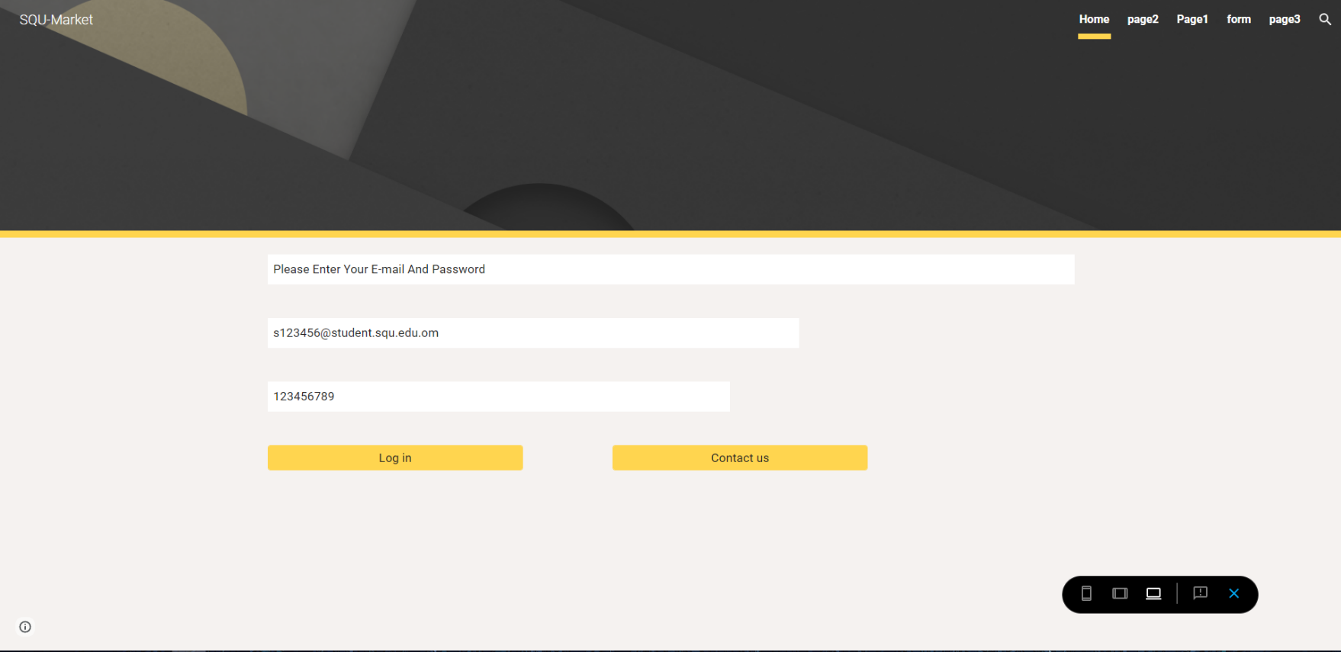

<https://sites.google.com/u/0/d/1kfuYLNYte0sCK0DPx7iDL5g6PeePAFrY/p/1GaZZM1cAkTxV-sqsJDwU4-BF13ehuSUc/preview>

# Impact issues

1. The financial impact: College students have a limited budget. Stock prices, the availability of money or grants. can have a huge impact on their financial situation. We should provide affordable options, student discounts, clearly explain pricing and security, etc.
2. Impact on academic and time management: College students are always on the go. They have classes, homework, and extra-curricular activities to keep up with. The ease of using an online shopping website affects how well they manage their time. We should focus on features such as fast shipping, easy navigation, and tracking of orders so that students can complete their purchases quickly and without any hiccups.

# Ethical and professional issues:

1. Data Security and Privacy: It's critical to handle students' financial and personal information with care. Our website needs to abide by data protection laws, encrypt private information. Furthermore, give students choices for consent and data control.
2. Fair Pricing and openness: Fair pricing policies and openness are two ethical issues. We should refrain from manipulating prices, offer precise and comprehensible pricing information. Promotions and discounts must be transparent and not deceptive.
3. Advertising and Marketing Responsibly: It's critical to use marketing strategies that are appropriate. We shouldn't encourage addictive behaviors (like compulsive shopping) or take advantage of financially strapped college students by deceptively advertising to them.

# Updated Website Structure:

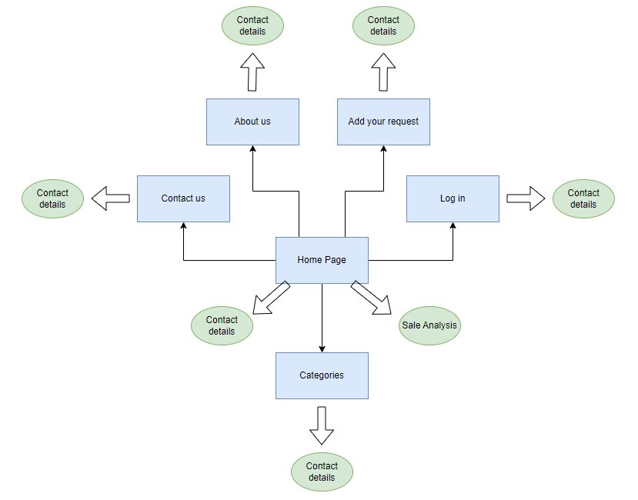

# Website Pages:

* **Home Page:** Which is the main page of the website. It contains a navigation bar, the categories of the market, analysis of sales of the businesses/services on the website and contact details.

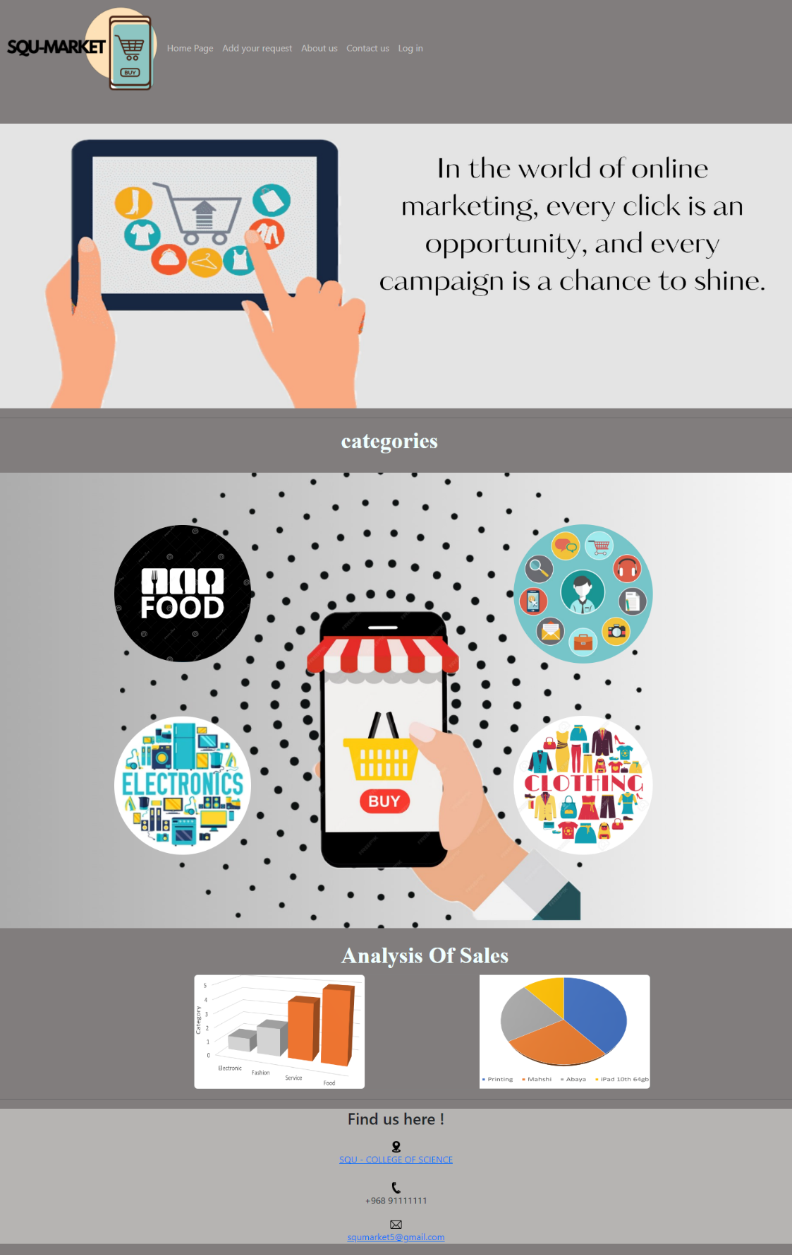

* **Add your request Page:** The page where you fill in a request form for adding your business/service. It contains a navigation bar and contact details.

* **About us Page:** The page that provides information about the founders of the website.

* **Contact us Page:** The page where you fill in a form to contact to the website founders.

* Log in Page: The page where you log in to the website.

# Website CSS/Bootstrap Styles Used:

External CSS Style:

* Used in the home page for headers, categories table and its columns.
* Used in the categories pages for the cards.
* Used in all pages for the footer.

Document CSS Style:

* Used in the Log in page for the background.

Inline CSS Style:

* Used in the home page for categories table columns and analysis table.
* Used in the categories pages.
* Used in all pages for most of the images used.
* Used in all pages for the footer.
* Used in the contact us page header.
* Used in the about us page for the headers and paragraphs.
* Used in the log in page header.

Bootstrap Layouts:

* Containers are used in all pages.
* Navigation bar is used in all pages.
* Grid is used in the categories pages.
* Forms are used in add your request page and contact us page.

# The Website:

**The website:** <https://batman70-m.github.io/SQU-MARKET.github.io/>

**The GitHub:** <https://github.com/Batman70-M/SQU-MARKET.github.io.git>

# Contribution Table:

|  |  |
| --- | --- |
| Ammar Abdullah Al Balushi 137497 | * The report |
| Ahmed Said Alghafri 129520 | * Design (footer and navigation for all pages, pages (colors, font, etc.)). * Coding (footer and navigation for all pages, Categories pages, Add your request page, Home page, contact us page, About us page with writing the text inside it, Log in page). |
| Mohammed Mattar Alshamsi 122711 | * Design (footer and navigation for all pages, pages (colors, font, etc.), images of page, categories of home page, cards). * Coding (Home page). * Get a sample accounts(Instagram) for each category). |